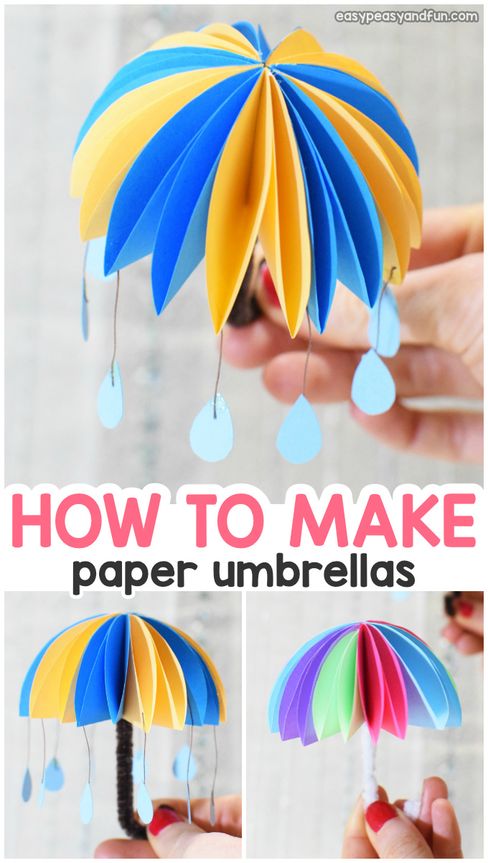
What is provided:
- color paper circles
- 1 light blue construction paper with Raindrops
- string
- 1 pipe cleaner
What you need:
- scissors
- glue
- 1 toothpick (for applying glue)
Let’s start!

Step by Step Instructions

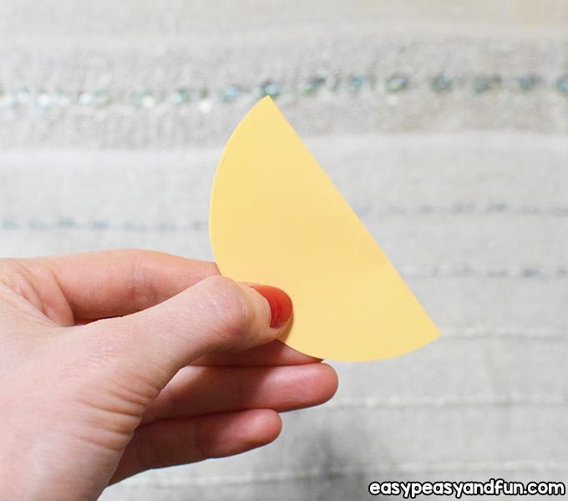
Making the Canopy
Start by folding one circle in half and do this for all your circles.

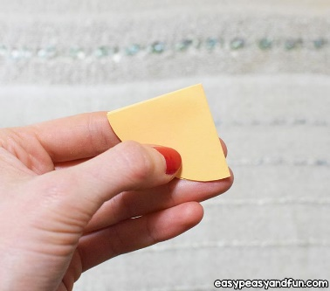
Then fold that piece in half too and the end piece should look like a
pizza slice.

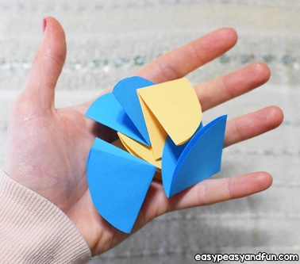
Repeat these steps with the rest of the circles.

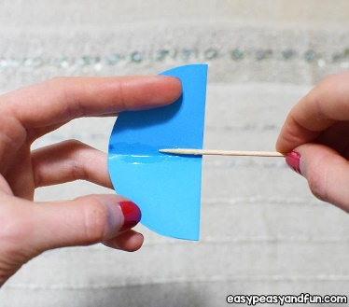
Open the pizza slice and apply some glue in between the corners.
You can help yourself with a toothpick or similar.

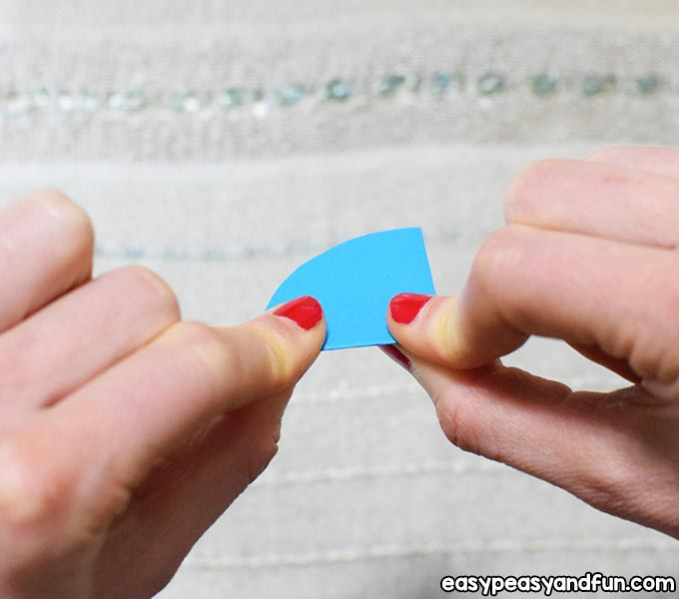
Then fold the piece again and press with your fingers until the glue dries or use clothespin or paper clip to hold the pieces together while the glue dries. Repeat this step with the rest of the circles.
Press it nicely.

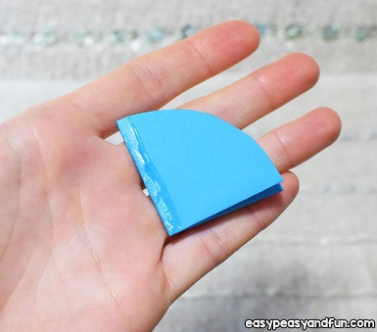
Put some glue on one end borderline …

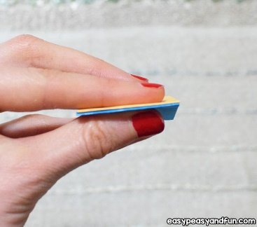
… then glue a pizza slice on.

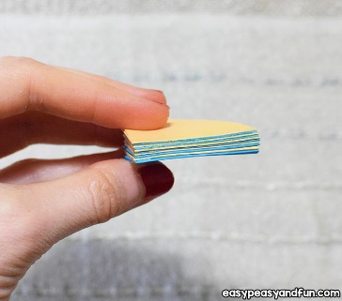
See the picture carefully and make sure you apply the glue on the right side so that we can open the umbrella afterwards.
Repeat this step with the rest of the slices and press with your finger until the glue is set (be patient).…
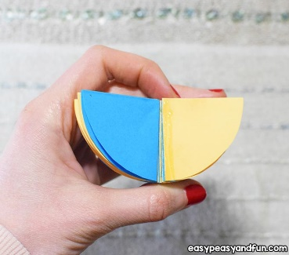
then open the umbrella …

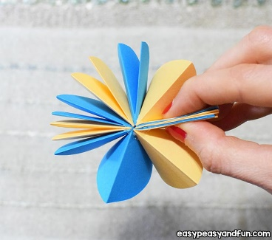

… and connect the ends. Hold until the glue dries. (Be Patient)

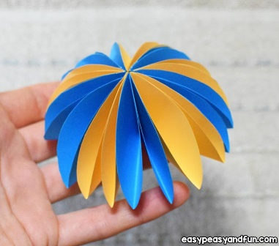
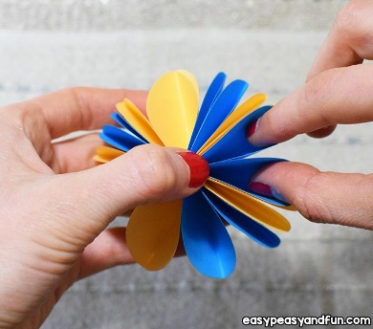
Using your fingers, widen the spaces of each pizza slice. That way we make them all equal. Like this.

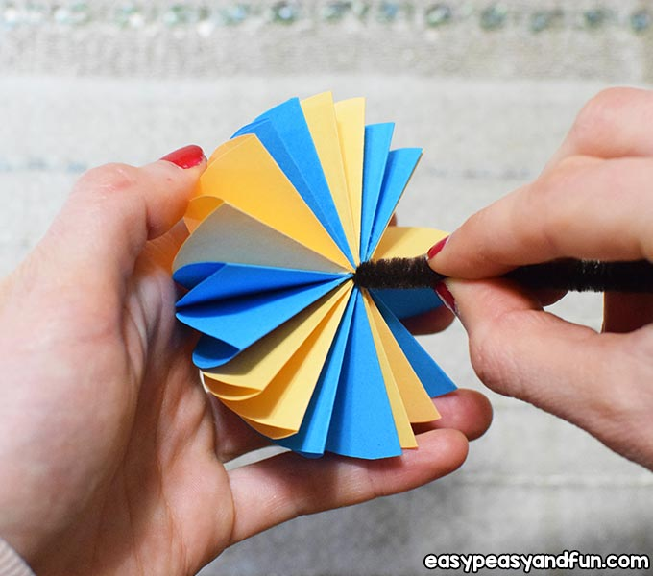
Take the pipe cleaner and carefully put it through the hole.

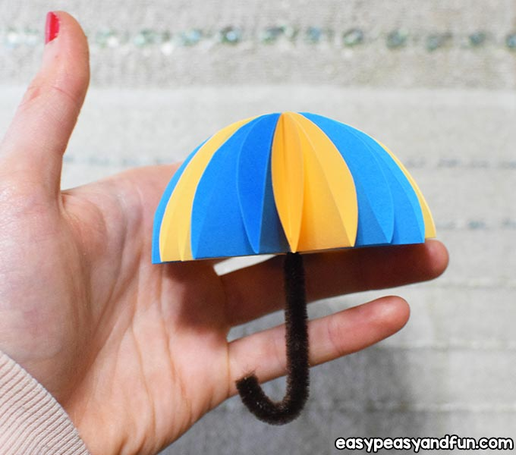
Then make a hook…

Your umbrella should look like this.

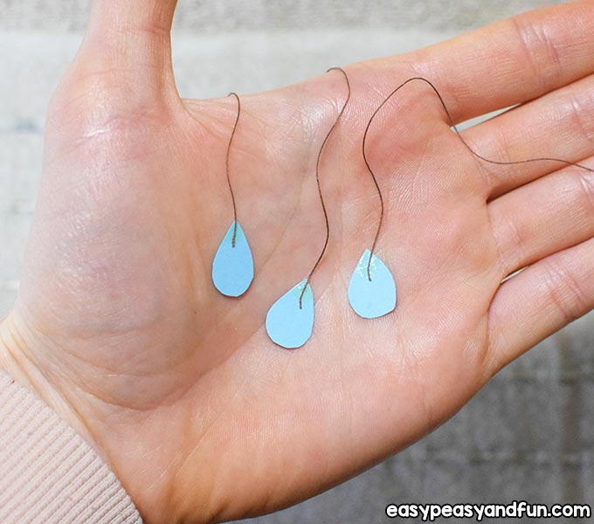
The Raindrops
Cut the raindrop shapes out.
Take 7 raindrops apply some glue on their tips and attach the yarn on.

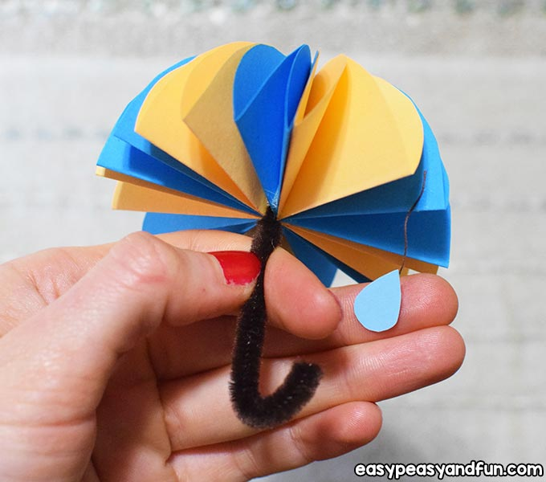
Apply some glue on some pizza slices and glue each of the yarns on the umbrella.

Do this for all your raindrops.

All done! Make as many as you like.

