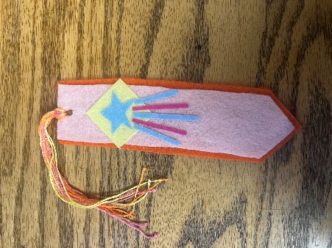
September Bookmark Craft Bag

Supplies Provided:
2 Felt Bookmark Shapes
3 Sticky pieces of Felt
6 Pieces of Colored Embroidery
Thread

Supplies Needed:
Glue
Scissors

Directions:
1. Choose one of the bookmark shapes to be the back of the bookmark.
2. Trim the other bookmark shape to fit inside of the back.
3. Glue the back to the front of the bookmark.
4. Take the embroidery thread all together and fold them in half.
5. Thread the fold through the hole in the bookmark and loop the ends through the loop/fold.
6. Decide on a design that you can make with the sticky pieces of felt and create the design.
7. Stick the design to the bookmark

8. Allow the glue to dry and now you have a completed bookmark!

Enjoy!

