Supplies Provided:  - 3 colorful popsicle sticks  - 1 white hat template  - 1 white square of cardstock  - 2 pieces of fabric  - 1 pop-pom  - 2 squares of felt  - 1 small rectangle of paper | Supplies Not Provided:  - Scissors  - White glue
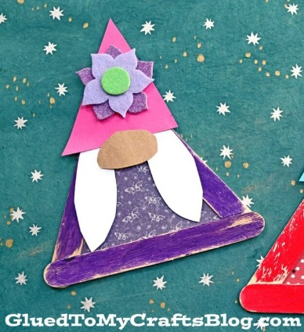
July Garden Gnome
Craft Bag Instructions

Step One: Take the three popsicle sticks and glue them to make a triangle. Let the triangle dry completely.
Step Two: Out of your largest piece of fabric, cut out a triangle big enough to fit the frame you just built. This will become the gnome body.
Step Three: Take your hat template and use it to cut out a hat from your smaller piece of fabric. Glue the hat template to your fabric hat. This will provide some stability so it doesn’t flop over.
Step Four: Cut either a beard or other hairstyle out of your square white paper.
Step Five: Cut a nose out of your small rectangle of paper.
Step Six: Glue the hat to the beard and then glue the nose half on top of the hat and half on top of the beard.
Step Seven: Cut out decorations out of your two pieces of felt. Also use the pom-pom. Glue as you desire. (We made ours into a flower).
Step Eight: Glue the large triangle onto the back of your gnome frame.
Step Nine: Flip over your gnome frame and glue on the head of your gnome on the top point of your gnome frame.
Step Ten: Let your gnome dry completely before moving it around.
You now have a Garden Gnome! Great job! :)
Tutorial found on gluedtomycraftsblog.com titled “Popsicle Stick Garden Gnome Craft Idea For Spring”

