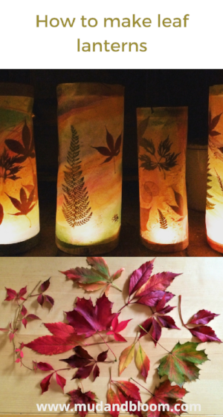
October Leaf Lantern Craft Bag

What we provide:
- wax or greaseproof paper
- String
- Card Stock Strips (2)
- Card Stock Square

What you will need:
- autumn leaves
- glue (I would recommend using the strongest craft glue you have).
- battery operated tea light
- a pencil
- scissors
- hole punch

What you need to do:

1. Go for a walk and collect some colorful autumn leaves. When you get home, press your leaves between the pages of some heavy books for two or three days, until they’re pressed flat and dried.
2. When your leaves are ready, take your sheet of greaseproof paper or wax paper. Fold it in half and then unfold.
3. Take your leaves and cover them in glue and stick them down onto the top half of the inside of the paper, spacing them evenly and leaving a bit of space at the edges.
4. Add glue to the remaining side of the paper and fold in half.
5. Take your two strips of cardstock and stick one along the top of the paper and one along the bottom. Then leave it to dry.
6. Then gently roll your greaseproof paper into a tube shape with the strips of card on the bottom and top. The strips should be on the outside of the roll. Then glue the two edges of the tube together, so they’re overlapping at least ½ in. You can add a staple at the top and bottom to secure if you’d like.
7. Take your tube and put it on top of a piece of card and draw a circle around its circumference. Then draw another circle round the first circle leaving a ½ inch gap, like in the photo below. Then draw lines between the two circles, like in the photo below.
8. Cut your outer circle out and cut the lines going into the middle circle.
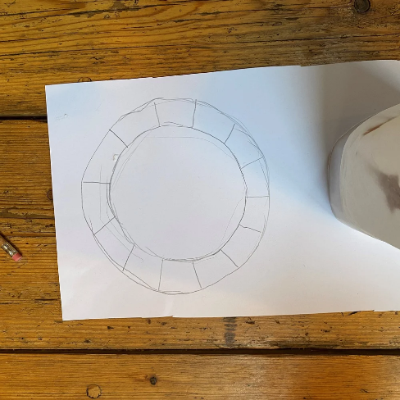
9. Fold the edges in so you have a bowl shape. Spread some glue over the back of the folds and insert it into the bottom of your lantern. Put your hand inside your lantern and press it from the inside and out so it sticks in place.
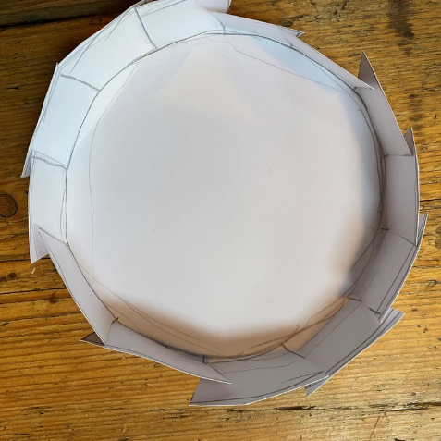
10. Punch two little holes at the top of your lantern on either side and loop your string into them. Make the string form a bridge over the top of your lantern.
11. Place your battery operated tea light into your lantern. When it's dark go for a little walk outside with it! You might want to use some blue tack, glue or something similar to secure your candle to the bottom of your lantern so it stays in one place.

Happy Crafting!

