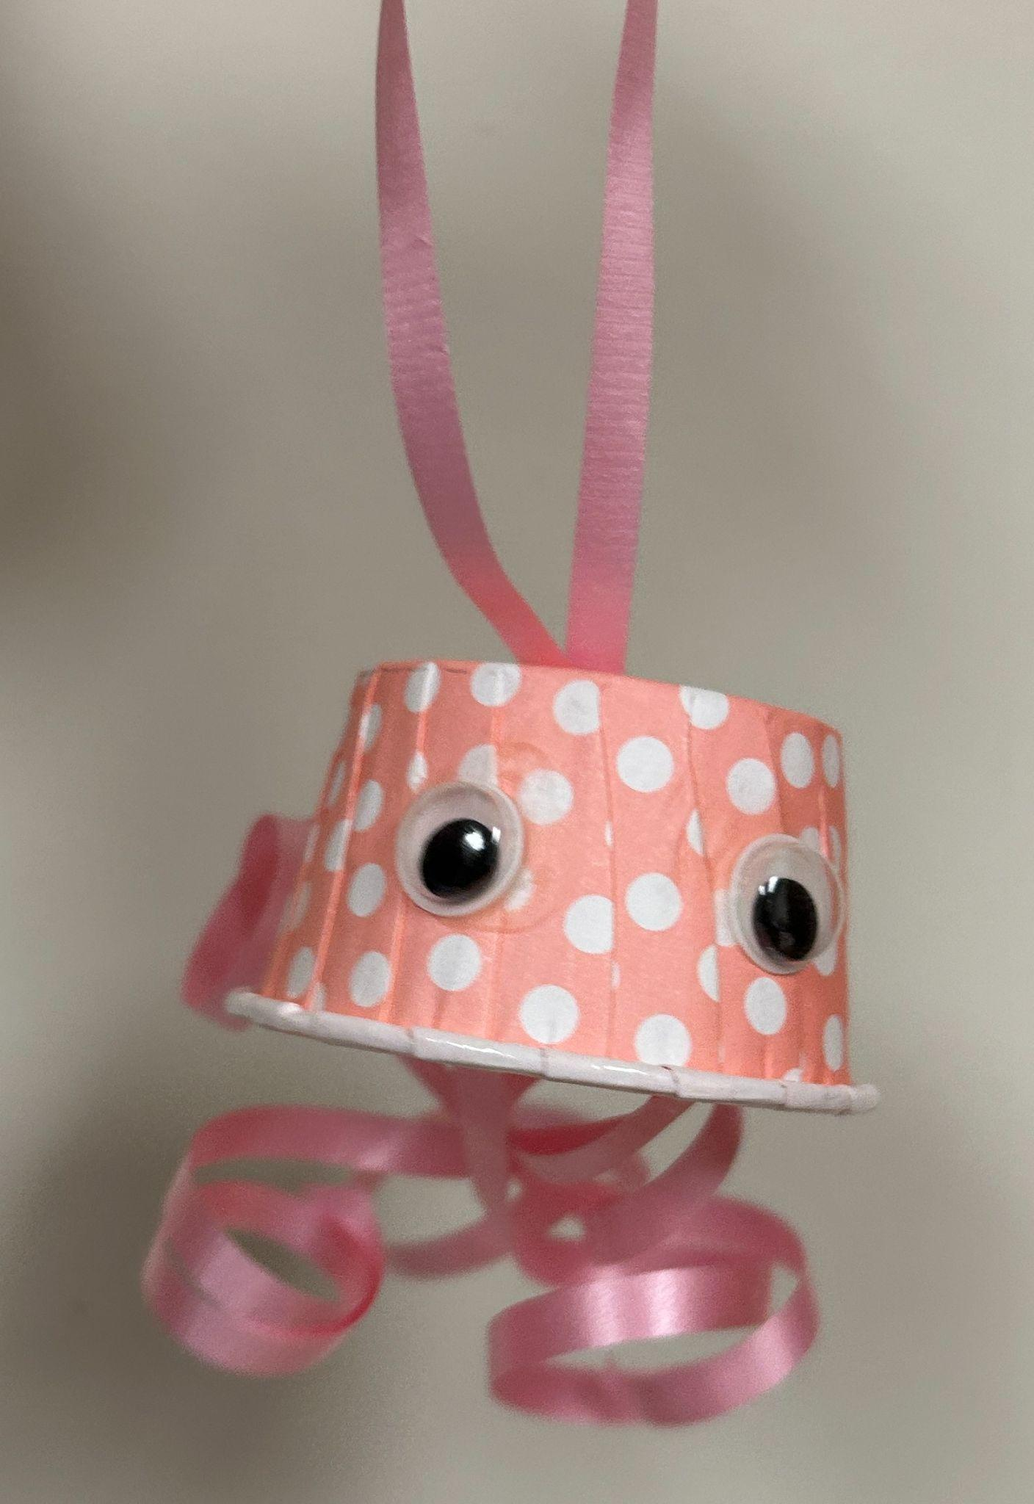
August Jellyfish Craft Bag

Supplies Provided:
1 small cupcake liner
2 Googly Eyes
1 Strip of Curling Ribbon
1 Small Cardstock Circle
2 Small White Circle Stickers

Supplies Needed:
Glue
Scissors

Directions:
1. Cut off about 8 inches of the curling ribbon
2. Tie a knot in the 8 inch piece to make a loop
3. Make a small slit in the center of the cupcake liner
4. Feed the Loop through the slit making sure to leave
the knot inside the cupcake liner.
5. Use the white circle stickers inside the cupcake liner
to secure the loop for hanging
6. Cut the remaining curling ribbon into 6 equal pieces
7. With the scissors curl one end of the ribbon

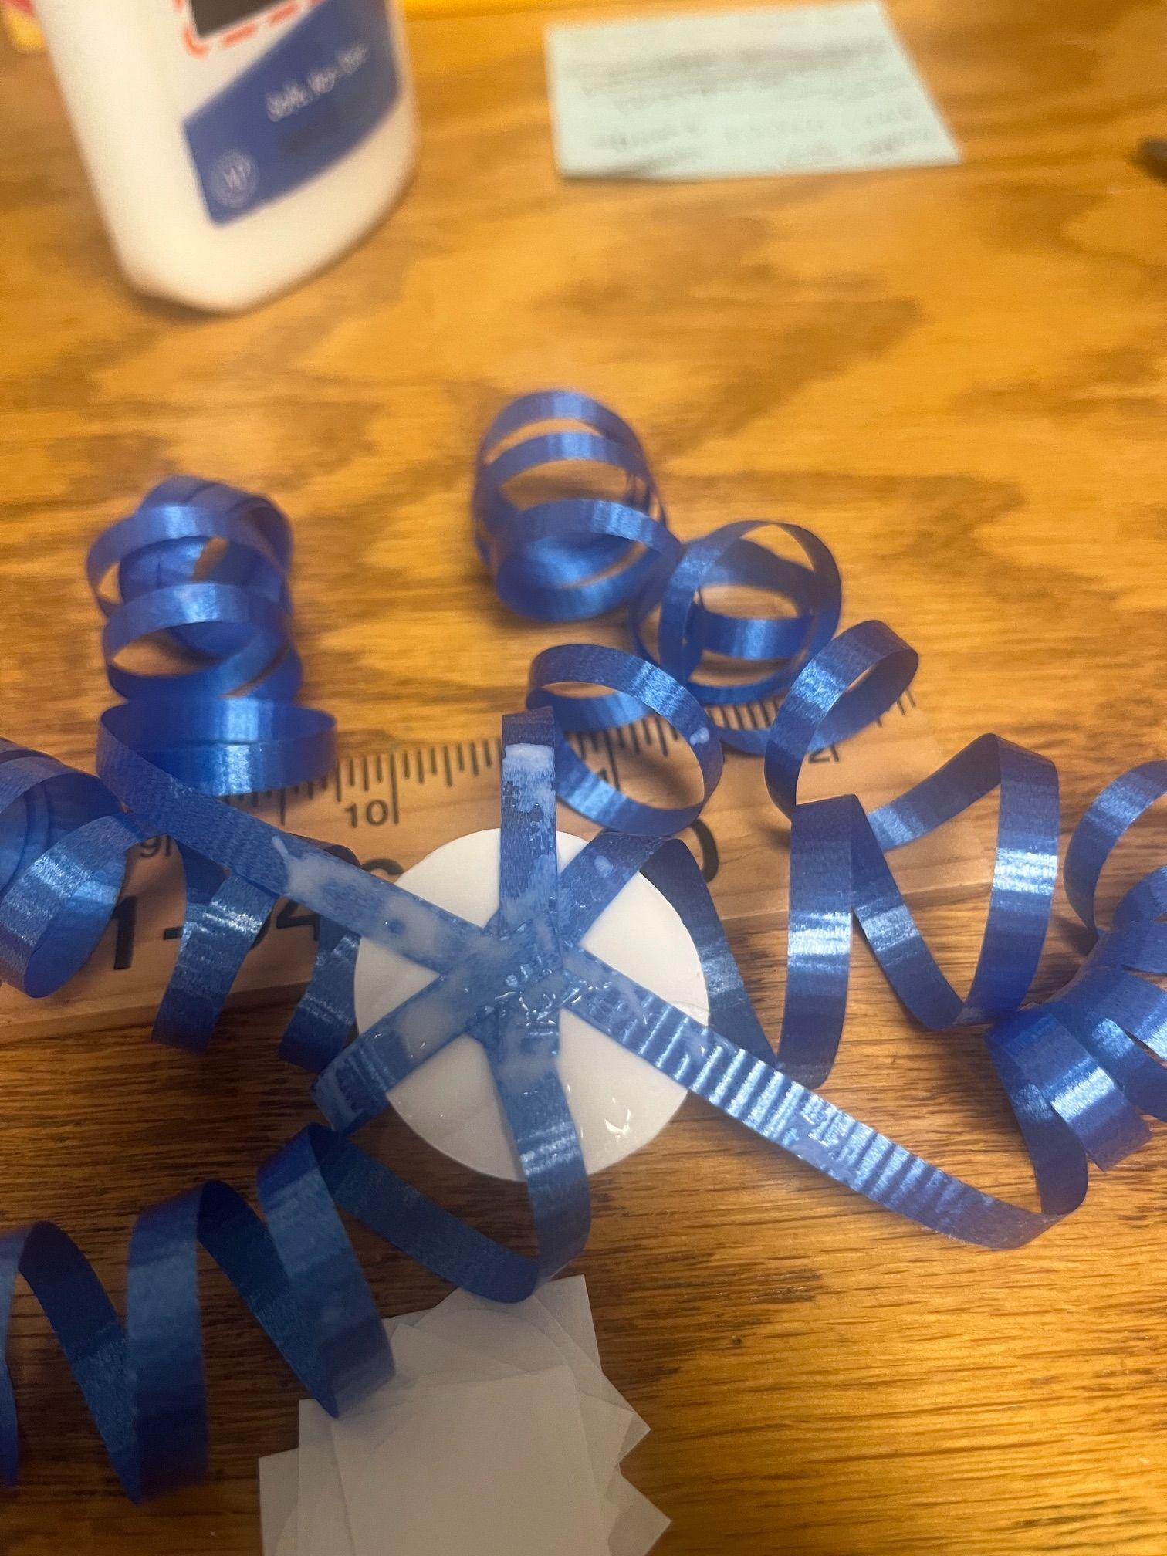
8. Glue the uncurled end of each ribbon to the white cardstock circle so each hang over around the circle evenly spaced as shown here:

9. Allow the glue to dry
10. Glue the googly eyes to the outside of the cupcake liner
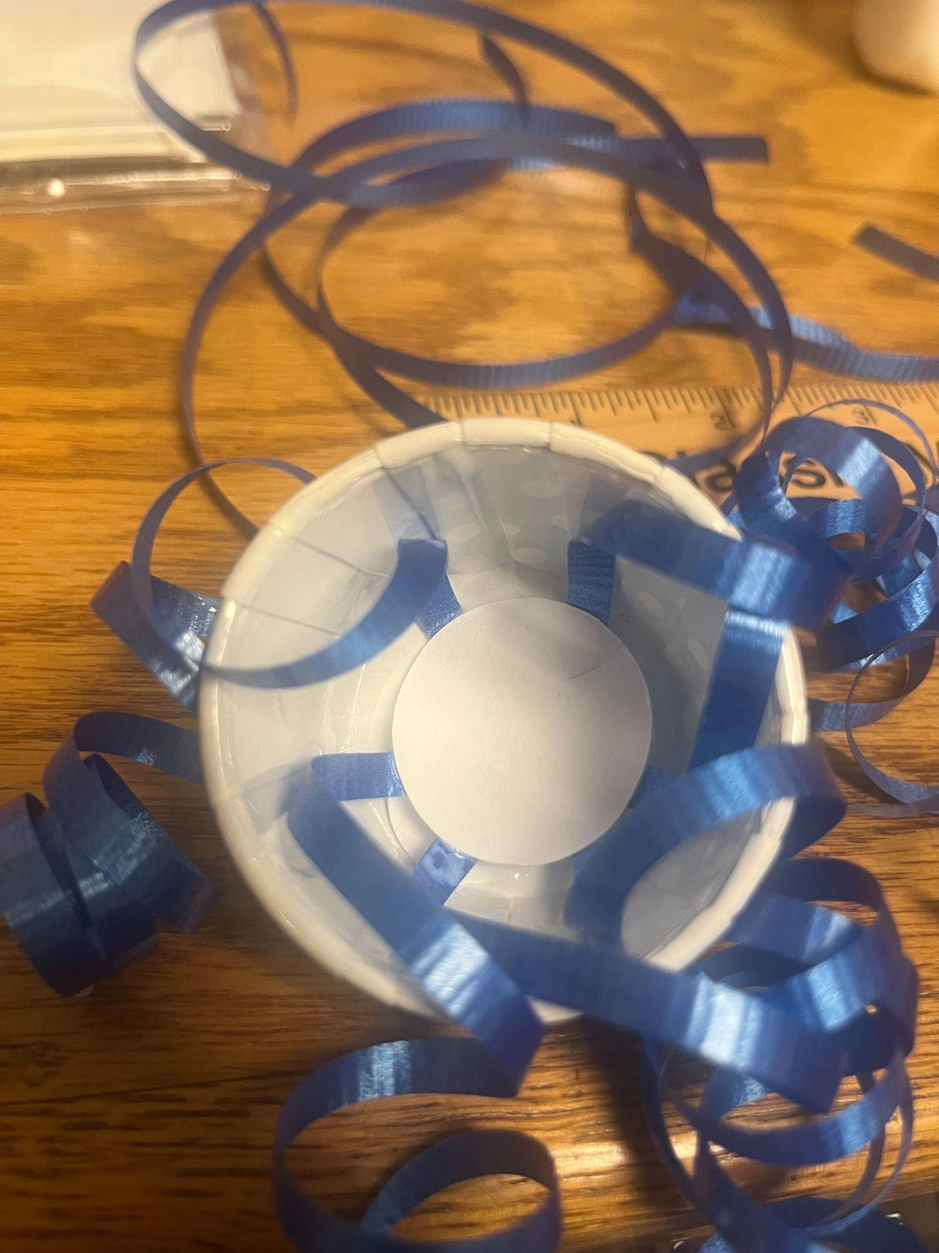
11. Allow the glue to dry.

12. Once the glue is dry add glue to the “bottom” of the cupcake liner and press the white cardstock circle into the cupcake liner as shown

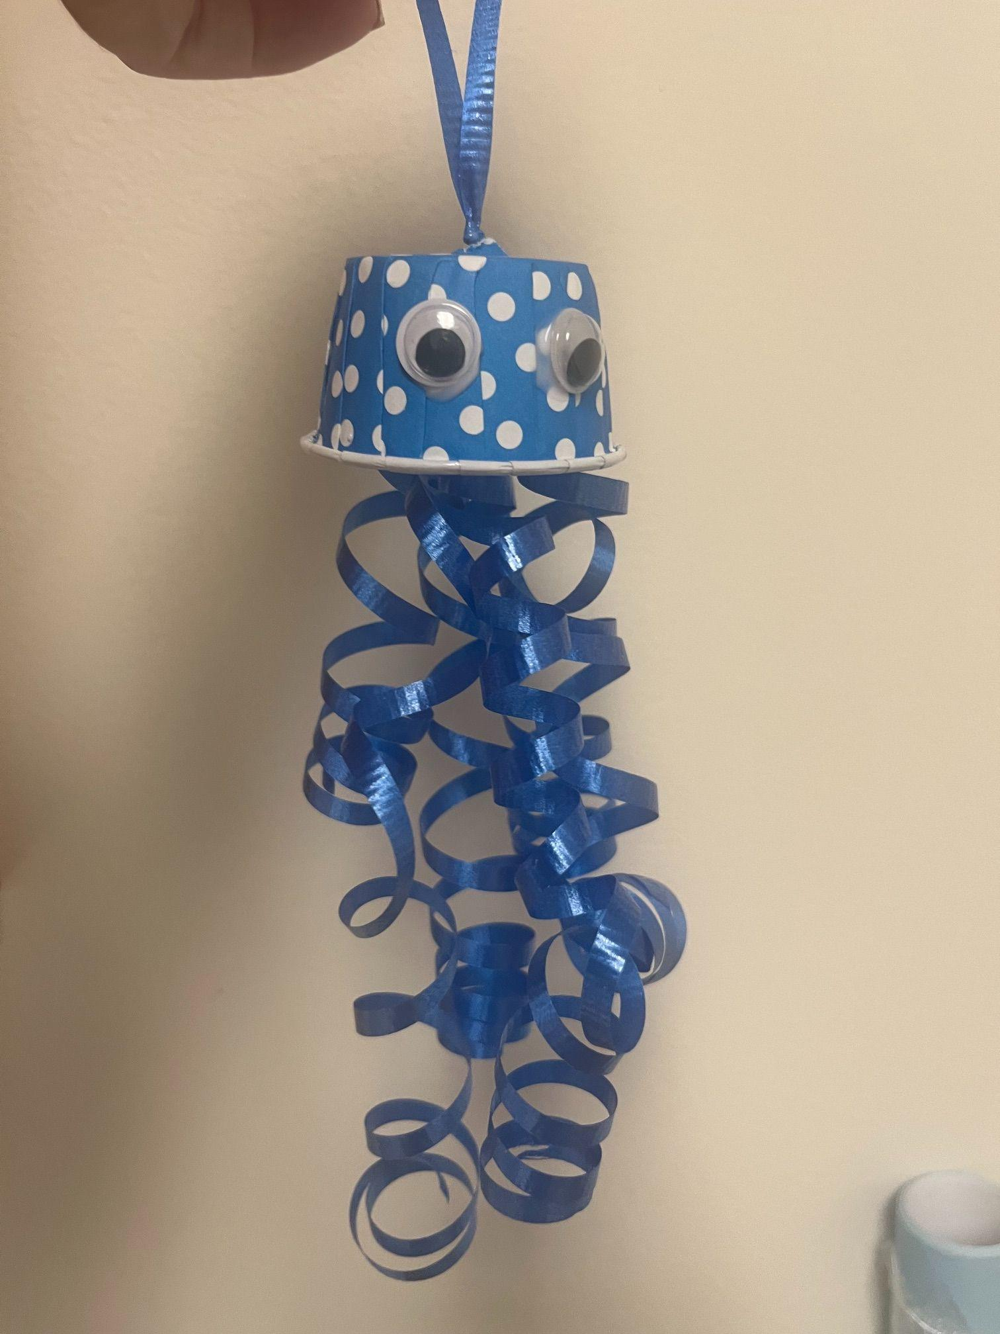
13. Allow the glue to dry and now you have a completed Jellyfish.

Enjoy!

