Supplies Provided:  - Four 11 by ½ inch strips of white paper  - Four 7 by ½ inch strips of white paper  - One 9 by ¾ inch strip of colored paper  - One small piece of orange paper  - Two mini cupcake liners | Supplies Not Provided:  - Scissors  - White glue  - A glue stick  - A crayon or marker
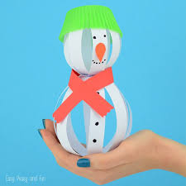
January Paper Snowman
Craft Bag Instructions

Step One: Take one of the long, white strips of paper and glue the ends together to make a circle.
Step Two: Take another long, white strip of paper and use a glue stick to attach one of the ends onto the circle you already made perpendicular. Loop the strip around the circle and glue the end on top of the other end.
Step Three: Repeat Step Two for the rest of the longest strips. This will make the bottom of your snowman. Place this ball in one of your cupcake liners to keep it steady.
Step Four: Repeat Step Two but for the SHORT white strips. This will make the head of your snowman.
Step Five: Loop the strip of colored paper to make a scarf. Place on top of your large ball.
Step Six: Use wet glue to attach the head to the bottom of your snowman.
Step Seven: Draw eyes, a mouth, and buttons on your snowman where you want his face to be.
Step Eight: Cut a triangle nose out of the orange piece of paper. Bend the wide part a bit to help it stick out like a carrot. Use a glue stick to put the nose on your snowman.
Step Nine: Use some wet glue and put it on top of your snowman’s head. Then add the final cupcake wrapper as a hat.
Step Ten: Let him dry! You’re all done! Pat yourself on the back because you did excellent work. Now the only question is, what are you going to name your snowman? :)

