Supplies Provided:  - Three popsicle sticks  - One plastic spider  - 3 ft of white yarn  - 1ft of white yarn | Supplies Not Provided:  - White paint  - White glue  - Scissors
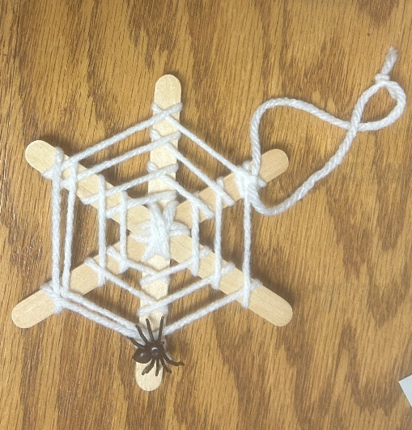
October Spider Web
Craft Bag Instructions

- Step One: Paint your popsicle sticks white (or color them whatever color you please). Let the paint dry.
- Step Two: Put some wet glue in the center of one of the popsicle sticks and then attach another popsicle stick so it forms a tall and skinny X.
- Step Three: Add some more wet glue in the center of that top popsicle stick, then place the third stick across the biggest gap of the X. This will form the base of your spider web.
- Step Four: Let the glue dry for a little while so your spider web doesn’t slide around.
- Step Five: Glue the end of the 3ft long white yarn to the middle of the top popsicle stick.
- Step Six: Wrap the white yarn around the center of your popsicle stick frame between each of the popsicle sticks TWICE. I recommend moving clockwise. Repeat all the way around your web frame. This will form the center of the web and add some extra support.
- Step Seven: Now, here’s the fun part. When the center of your web is held together with the yarn and the end of the yarn is behind your frame, we’re going to start the web weaving process. Take the yarn, wrap it once around the popsicle stick on the right, the yarn should come out on top of the stick and be heading towards the left. Place this end of the yarn over the next popsicle stick in the line before wrapping it underneath and back over top. Repeat in a circle until your yarn reaches the tippity top of your web frame.
- Step Eight: Glue the end of the yarn of the to the frame, cut off any excess.
- Step Nine: Glue the spider onto your web anywhere you’d like.
- Step Ten: Carefully, decided which popsicle stick you want to be the top of your web. Take the 1ft long white yarn and secure it underneath the top strand of your web, tying it well and creating a loop to hang your project from.
- Step Eleven: Let the glue all dry before hanging it up. Well done, your project looks amazing! I hope you had fun! :)

